Reference for everything: <https://www.cs.princeton.edu/courses/archive/fall18/cos333/project.html>

CHECK PIAZZA FOR SPECIFICS THAT MAY NOT BE ON THE REFERENCE ABOVE

To-Do:

* Overall:
  + Fill in timeline to best of our knowledge (ALL)
  + **User’s Guide** (ISHAN)
    - **DONE**
  + **Programmer’s Guide** (ISHAN W/ SUPPORT OF PAULO / OTHERS)
  + Make sure everything is named properly (ALL)
  + **User testing** (PAULO - SENDING OUT FORM TONIGHT)
    - Aim for at least 20 users -> solicit feedback and list it in the evaluation document
  + **Project Evaluation document** - (ALL - I think the best way to do this is for each of us to go through and provide our own insights on the process and the challenges and whatnot)
  + **Product Evaluation document** - (ISHAN W/ SUPPORT OF OTHERS)
  + Put source code in the drive - ALL
  + **Ensure that code is BUG-FREE**
    - Student profile bars - **DONE**
    - Double click - **DONE**
    - When you remove someone from watchlist in a split screen, the screen rerenders - **DONE**

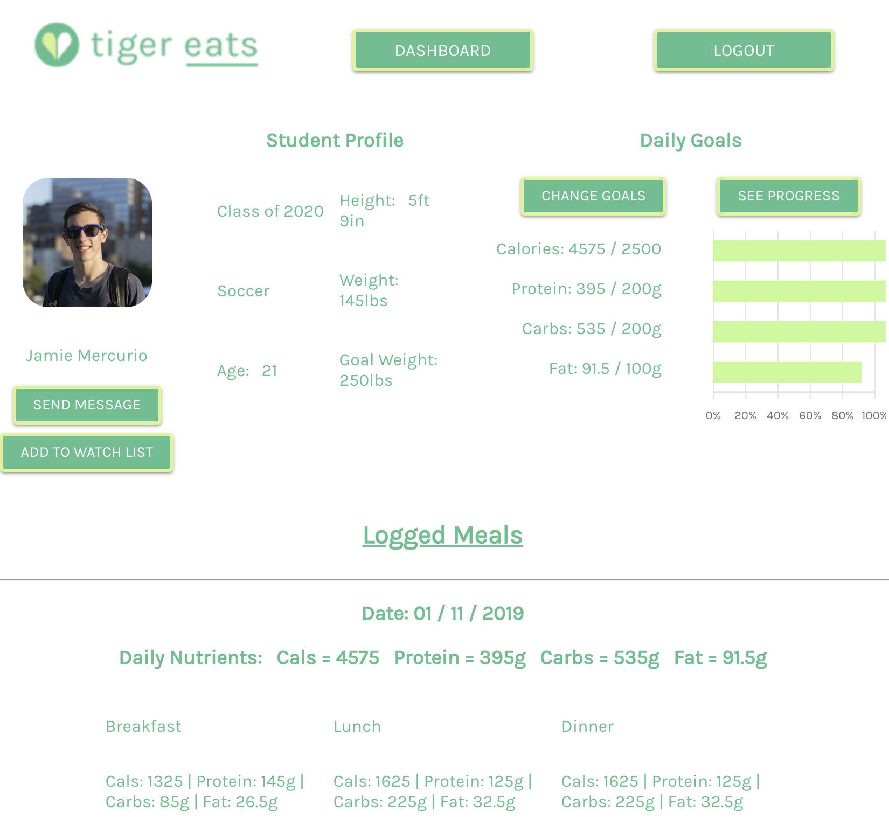 ---> . 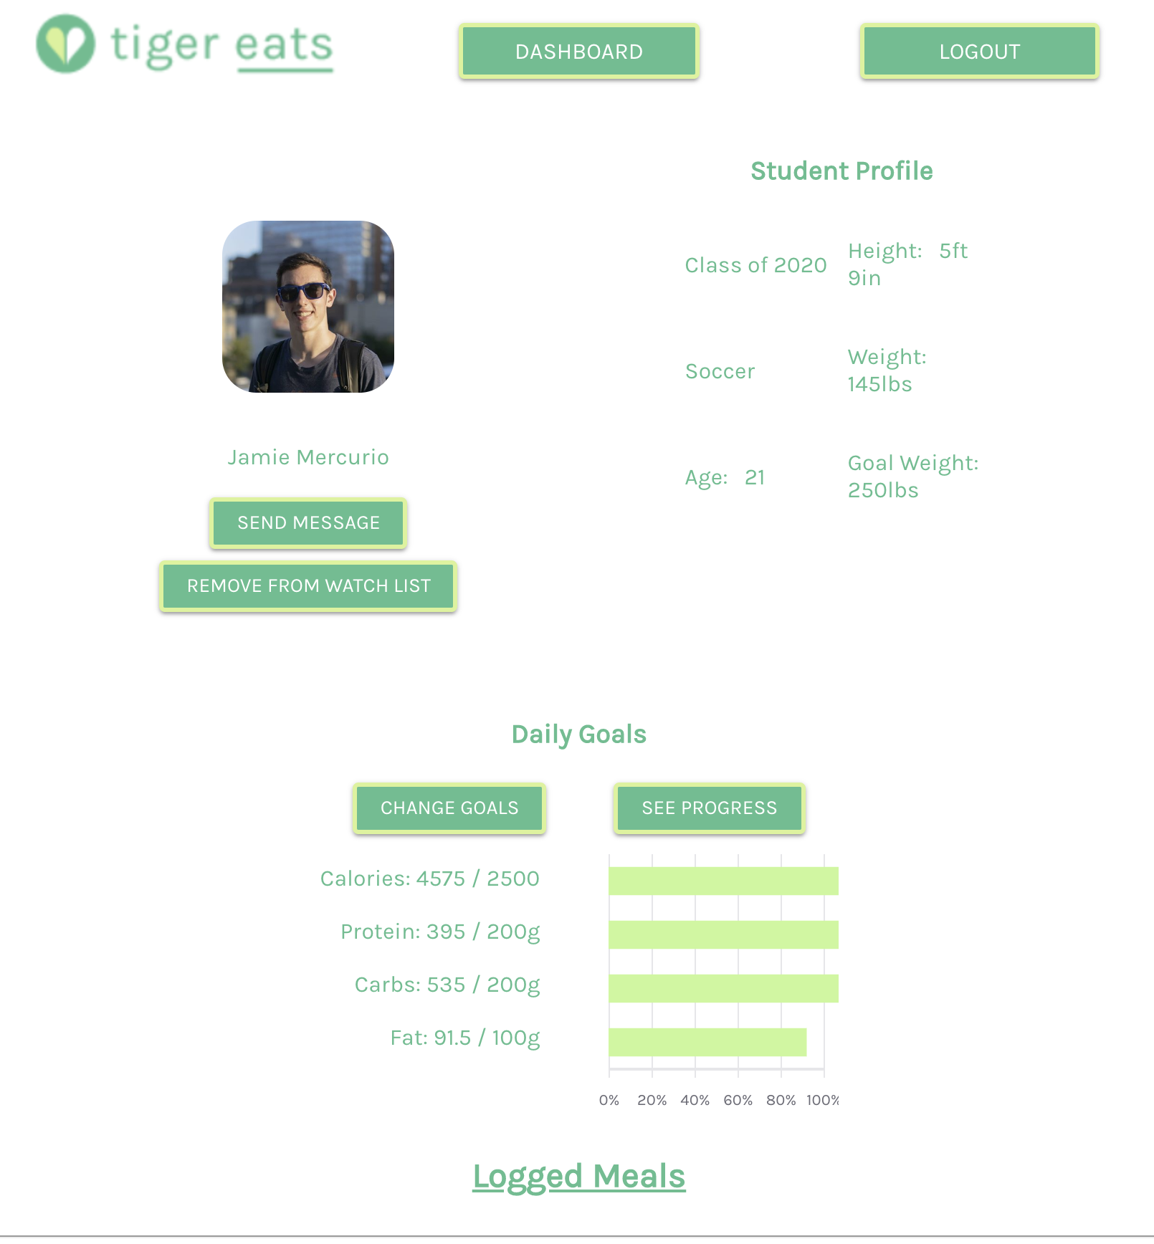

* + - Change the error message when inputting calories and macronutrient percentage breakdown (right now, it just says “Valid values only!” but doesn’t explain what’s invalid) - **DONE**
    - Change goals by calorie goal and percentages -- should probably be able to handle “10%” as an input. Right now it only works with numbers. Solution is split the string by a space and only take the first index and to check if the last character of the 0th index is a ‘%’ or not. - **DONE**
    - Not a bug, but if possible, it would make sense to have a “Watchlist?” checkmark in the dashboard - **DONE**
    - Progress page has some glitches in being responsive in a split screen - **DONE**

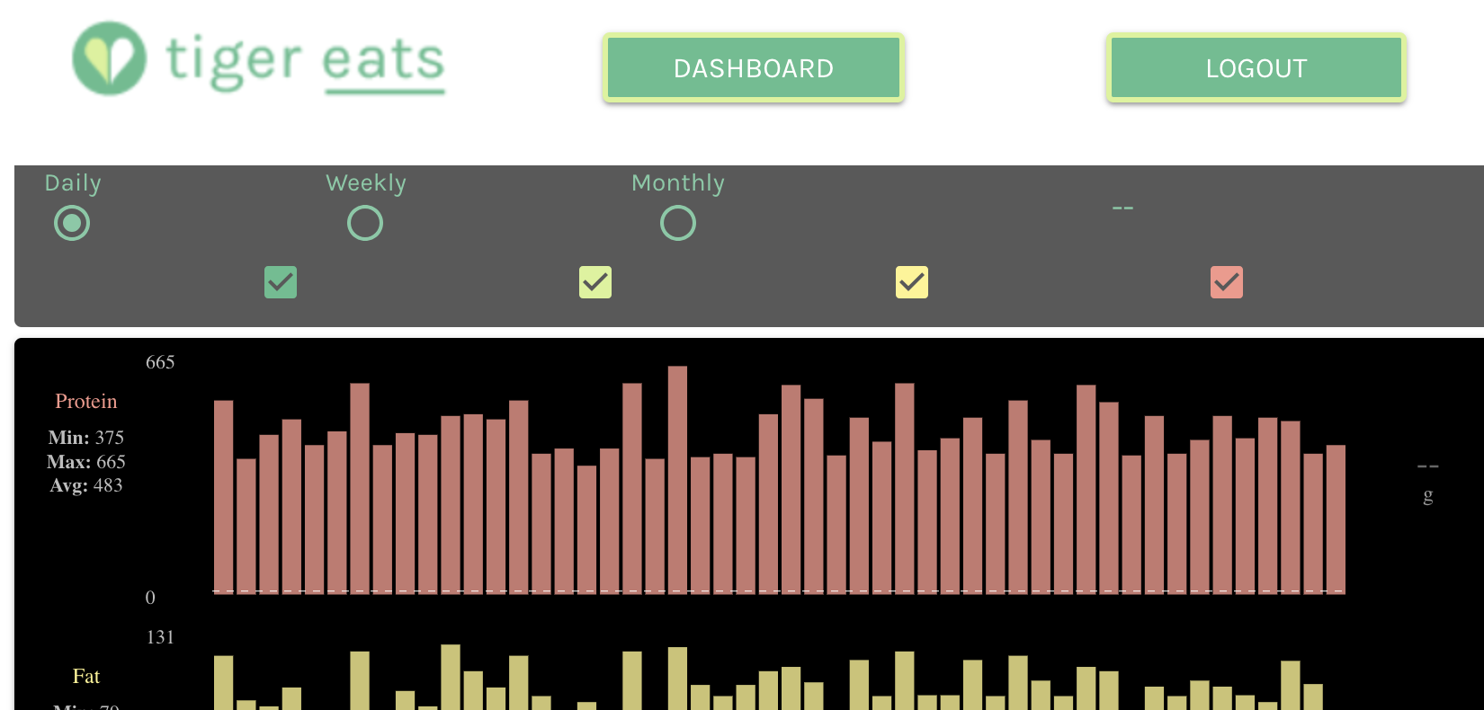

* + **REMOVE “ADD NOTES” IF WE CAN’T IMPLEMENT IT - DONE**
  + **Login strategy** - **DONE**
  + Height threshold
  + Brush info (Evaluation)
  + Change date (Evaluation) - **DONE**